**A**

### **Project Report**

### **On**

### **GrainsMart**

**Submitted by**

### **Shubham Hiralal Giramkar**

**Roll No.: 22318**

**MCA–I**

**SEM–I**

**Under the guidance of**

### **Dr.Milind Godase**

**For the Academic Year 2022-23**



***Sinhgad Technical Education Society’s***

**Sinhgad Institute of Management**

**Vadgaon Bk Pune 411041**

**(Affiliated to SPPU Pune & Approved by AICTE New Delhi)**

### 

### Date:

**CERTIFICATE**

This is to certify that Mr. Shubham Hiralal Giramkar has successfully completed his project work entitled **“GrainsMart”** in partial fulfillment of MCA – I SEM –I Mini Project for the year 2022-2023. He has worked under our guidance and direction.

### Dr.Milind Godase Dr. Chandrani Singh

**Project Guide Director, SIOM-MCA**

### Examiner 1 Examiner 2

**Date:**

**Place:** Pune

**DECLARATION**

I certify that the work contained in this report is original and has been done by me under the guidance of my supervisor(s).

* The work has not been submitted to any other Institute for any degree or diploma.
* I have followed the guidelines provided by the Institute in preparing the report.
* I have conformed to the norms and guidelines given in the Ethical Code of Conduct of the Institute.
* Whenever I have used materials (data, theoretical analysis, figures, and text) from other sources, I have given due credit to them by citing them in the text of the report and giving their details in the references.

### **Name and Signature of Project Team Members**:

|  |  |  |  |
| --- | --- | --- | --- |
| **Sr. No.** | **Seat No.** | **Name of students** | **Signature of students** |
| **1** | 22318 | **Shubham Hiralal Giramkar** |  |

**ACKNOWLEDGEMENT**

It is very difficult task to acknowledge all those who have been of tremendous help in this project. I would like to thank my respected guide **Dr. Milind Godase** for providing me necessary facilities to complete my project and also for their guidance and encouragement in completing my project successfully without which it wouldn’t be possible. I wish to convey my special thanks and immeasurable feelings of gratitude towards **Dr. Chandrani Singh, Director SIOM-MCA.** I wish to convey my special thanks to all teaching and non-teaching staff members of **Sinhgad Institute of Management, Pune** for their support.

Thank You

Yours Sincerely,

**Shubham Hiralal Giramkar.**

# **INDEX**

|  |  |  |
| --- | --- | --- |
| **Sr. No.** | **Chapter** | **Page No.** |
| 1 | **CHAPTER 1:** **INTRODUCTION** |  |
| 1.1 | Abstract |  |
| 1.2 | Existing System and Need for System |  |
| 1.3 | Scope of System |  |
| 1.4 | Operating Environment Hardware and Software |  |
| 1.5 | Technology Requirements |  |
| 2 | **CHAPTER 2: PROPOSED SYSTEM** |  |
| 2.1 | Feasibility Study |  |
| 2.2 | Objectives of the proposed system |  |
| 2.3 | Module Specifications |  |
| 3 | **CHAPTER 3: ANALYSIS AND DESIGN** |  |
| 3.1 | Entity Relationship Diagram (ERD) |  |
| 3.2 | Class Diagram |  |
| 3.3 | Use Case Diagrams |  |
| 3.4 | Activity Diagram |  |
| 3.5 | Sequence Diagram |  |
| 3.6 | Component Diagram |  |
| 3.7 | Table Design |  |
| 3.8 | Data Dictionary |  |
| 3.9 | Sample Input and Output Screens  (Screens must have valid data. All reports must have at-least 5 valid records.) |  |
| 4 | **CHAPTER 4: CODING Sample code** |  |
| 5 | **CHAPTER 5: LIMITATIONS OF SYSTEM** |  |
| 6 | **CHAPTER 6: PROPOSED ENHANCEMENTS** |  |
| 7 | **CHAPTER 7: CONCLUSION** |  |
| 8 | **CHAPTER 8: BIBLIOGRAPHY** |  |

**CHAPTER 1: INTRODUCTION**

* 1. **Abstract:**
* The “**GrainsMart**” has been developed for provide platform for **farmers to sell** their grains **directly to customer**.
* Customer can order grains directly from farmers.
* This Software allows to customers for buy grains from their regular seller as well as new seller farmer.
* It also allows for customer to order grains in best price from farmers.
* This System is designed for to simplify market process.
  1. **Existing System and Need for System:**
* **Existing System:**
* The Existing system is **manual** and **offline** system.
* The customers and farmers are **goes to the market** and sells and buy the grains.
* The complete process depends on the **physical interaction**.
* **Not Online platform** available for farmers to sell their grains.
* This existing system is very **time consuming**.
* **Need For System:**

* To overcome the drawbacks.
* Because in online system maintaining Bill-records get easy.
* Distributors get a platform to sell their products.
* Customer get platform to purchase their product.
  1. **Scope of System:**
* Easily get the in detail information about the grains.
* Safe-way for the ordering and delivering process.
* No need of the travelling for customers and farmers.
* Enable for online payment.
* Allows for faster service than existing system.
* Easy, user-friendly GUI.
* Time Saving.

**1.4 Operating Environment Hardware and Software**

* **Hardware Requirements:**

**PROCESSOR:** AMD RYZEN 3

**RAM:** 1GB+ DDR

**HDD:** 40GB

* **Software Requirements:**

**OPERATING SYSTEM:** Windows/MacOS/Linux

**WEB BROWSER:** Mozilla Firefox, Google Chrome etc.

* 1. **Technology Requirements:**

**Front End:**

HTML

CSS

Java-Script

**Back End:**

1. MY-SQL

2. Java

**CHAPTER 2: PROPOSED SYSTEM**

* 1. **Feasibility Study:**
* **Economical Feasibility:**

* This is a very important aspect to be considered while developing a project. We decided the technology based on minimum possible cost factor.
* All hardware and software cost has to be borne by the organization.

* Overall we have estimated that the benefits the organization is going to receive from the proposed system will surely overcome the initial costs and the later on running cost for system.

* **Technical Feasibility :**
* This included the study of function, performance and constraints that may affect the ability to achieve an acceptable system.
* For this feasibility study, we studied complete functionality to be provided in the system, as described in the System Requirement Specification (SRS), and checked if everything was possible using different type of frontend and backend platforms.
* **Operational Feasibility :**
* No doubt the proposed system is fully GUI based that is very user friendly and all inputs to be taken all self-explanatory even to a layman.
  1. **Objectives of The Proposed System:**
* The main **objective** of this project is to **make a platform for farmers** to sell their grains in digital market.
* To make a website for **customers** for **order** grains **directly from farmers**.
* The Purpose of the project is to build a website to **reduce** the **manual and offline work**.
* This application is built in such way that it should **suits** for all types of customers and farmers in future.
* The **GrainsMart** provides grain prices directly from farmers to order grains so customer can order different qualities of grains with **proper** **cost**.
  1. **Module Specifications:**
* **Farmers Module:**

**1.Login/Register:** The Registration Module holds basic information related to registrations. From within this module, farmers will be logging.

**2.Sell Grains:** After Login Farmer can add their grains details for selling like price ,total stock ,variety.

**3.Update Stock and Price:** Using this module farmers can change their grains total stock and grains price.

**4.Customers History:** Customer history module helps for farmers to see their previous customers details.

**5.Transactions Module:** Using transaction module farmers can see their total payment transactions.

**6.Profile Module:** Farmers can see and update their profile using profile module.

* **Customers Module:**

**1.Login/Register:** The Registration Module holds basic information related to registrations. From within this module, farmers will be logging.

**2.Select Grains:** After Login customers need to select grains which they have need to buy, In this module customer can see many varieties of grains and their selling price.

**3.Select Farmer:** If grains are selected buy customer then they can see all farmers with selected grains varieties for buying grains from selected farmers.

* **Order Module:**

**1.Generate Bill:** In this module total bill of selected grains are generated.

**2.Cancel Order:** In this module customer can cancel the order of grains.

**3. History Module:** In History module customer can see their all previous orders history.

* **Payment and Delivery Module:**

In this payment module customer can pay total bill of ordered grains.

In Delivery Module customer can see their ordered grains status.

**CHAPTER 3: ANALYSIS AND DESIGN**

**3.1 Entity Relationship Diagram (ERD):**

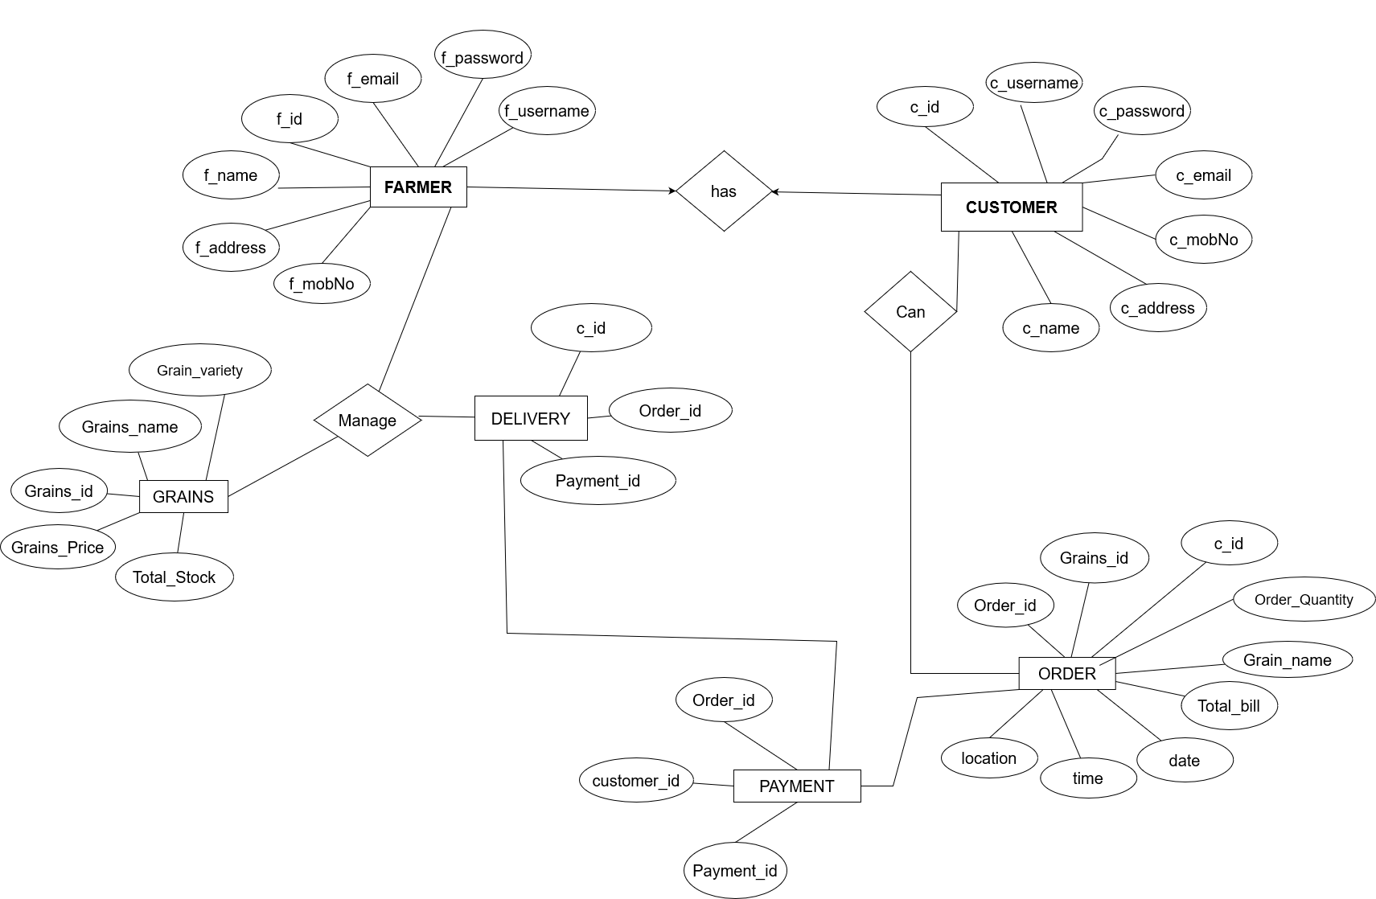

**3.2 Class Diagram:**

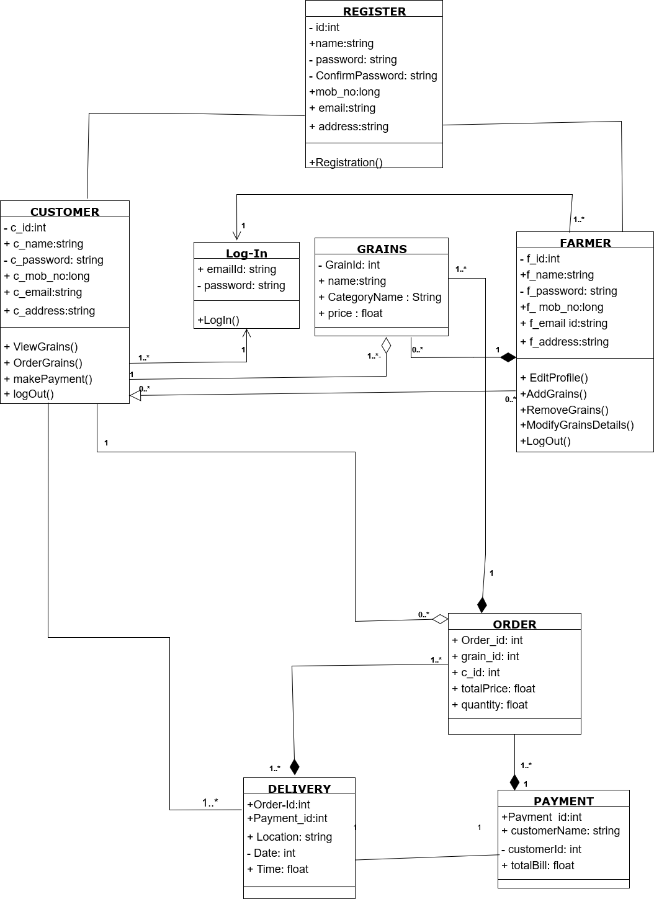

**3.3 Use Case Diagrams:**

USE CASE DIAGRAM FOR CUSTOMER

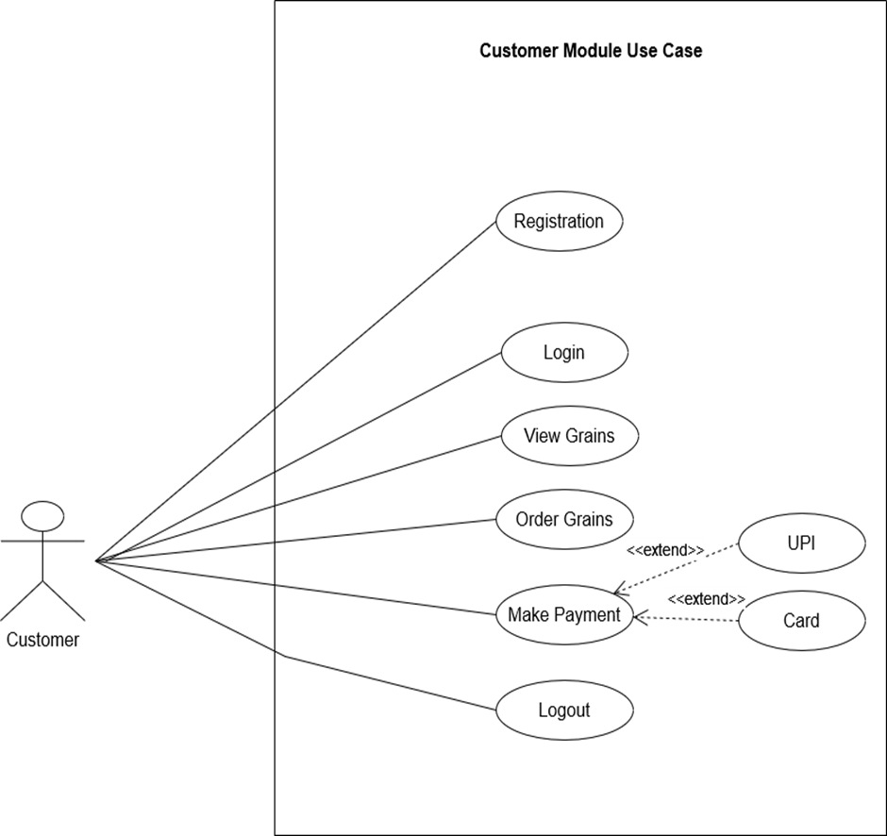

USE CASE DIAGRAM FOR FARMER

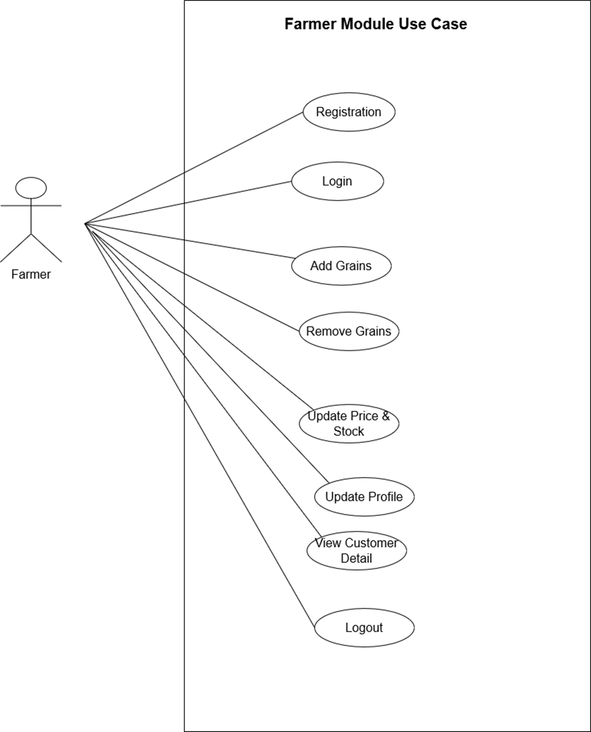

USE CASE DIAGRAM FOR ORDER

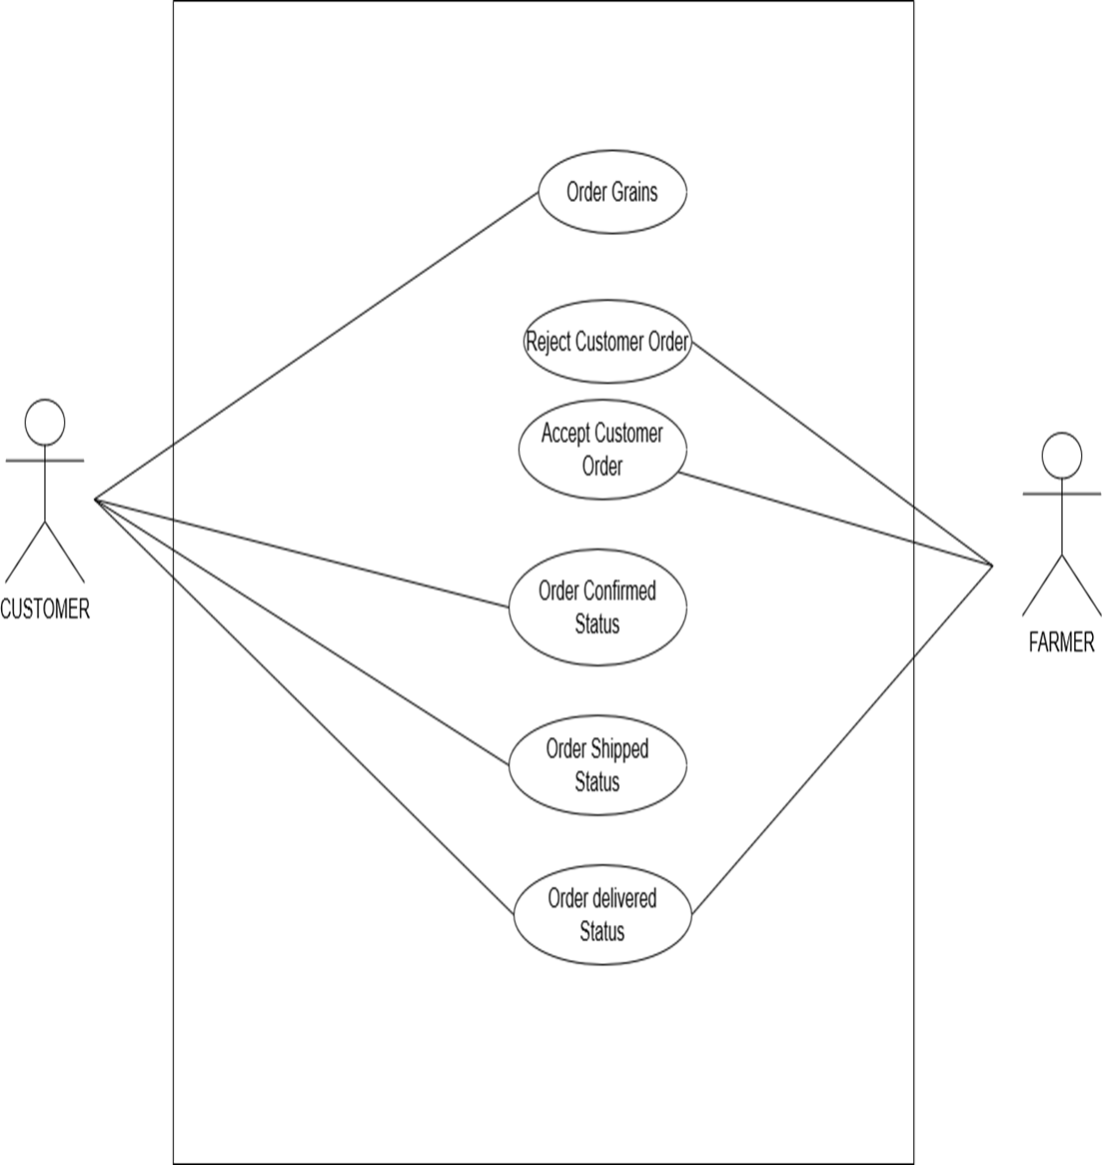

USE CASE DIAGRAM FOR PAYMENT AND DELIVERY

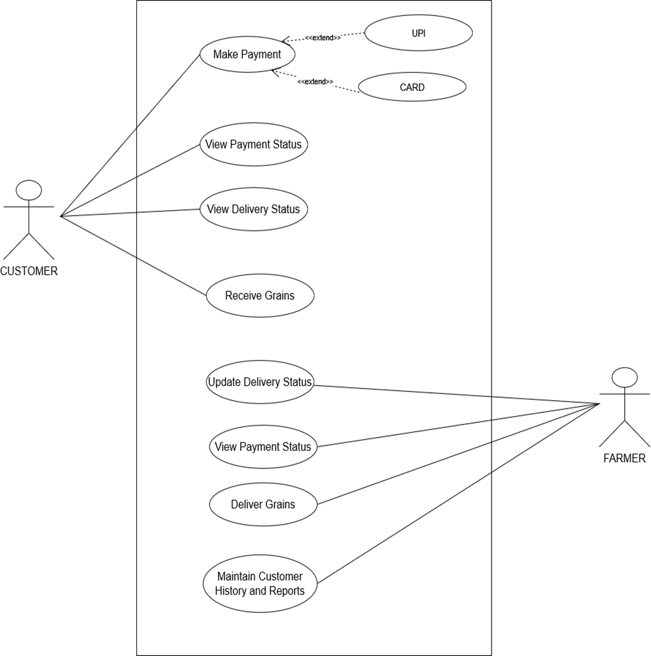

USE CASE DIAGRAM FOR GRAINS

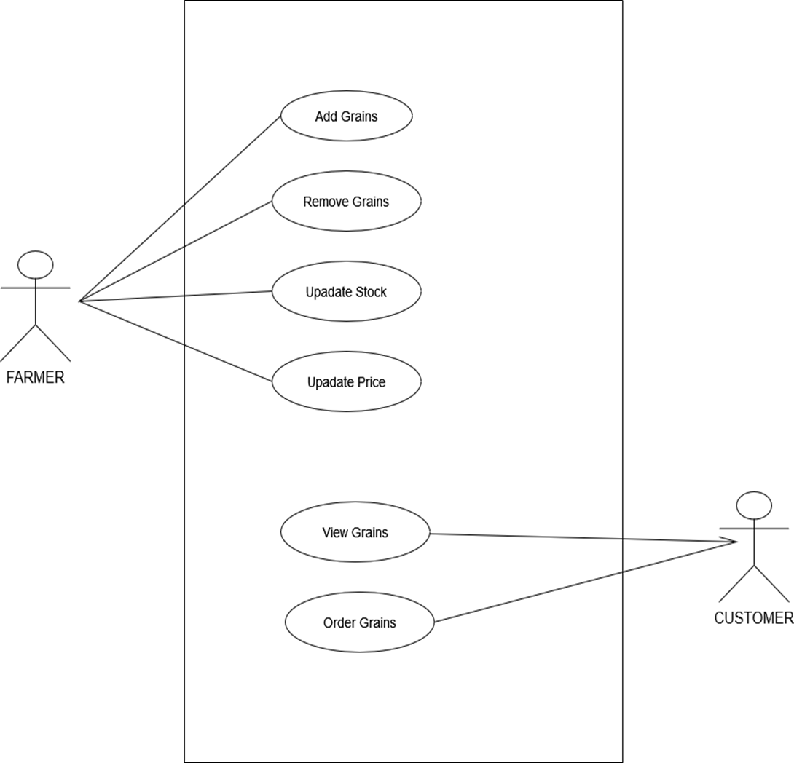

**3.4 Activity Diagram:**

ACTIVITY DIAGRAM FOR CUSTOMER

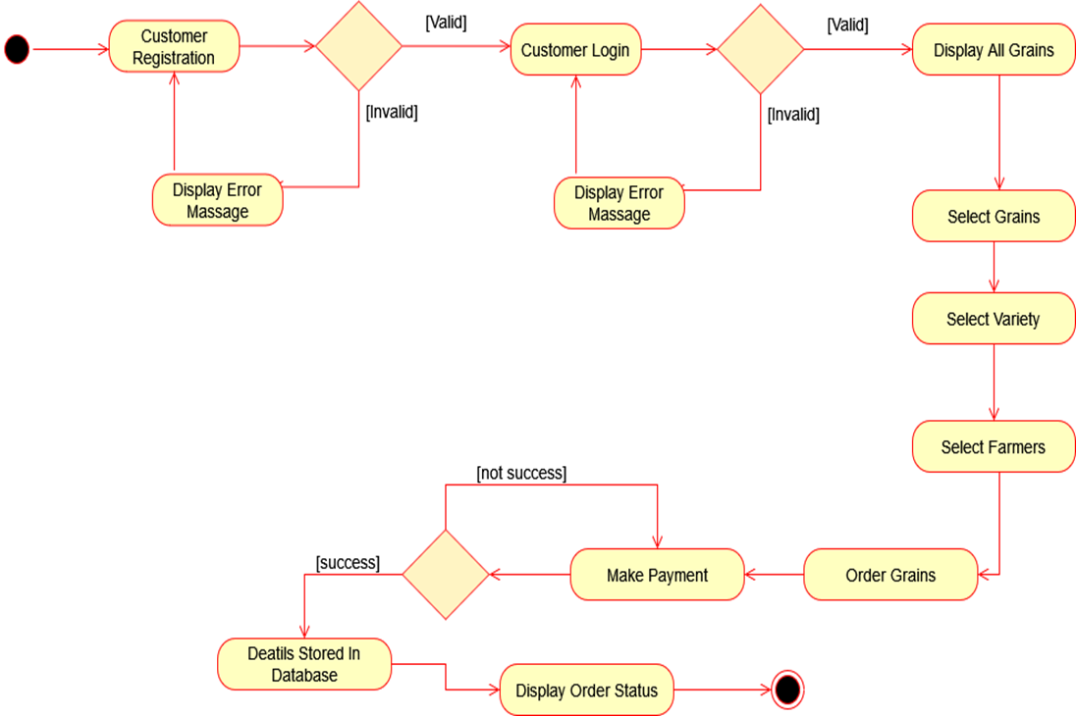

ACTIVITY DIAGRAM FOR FARMER

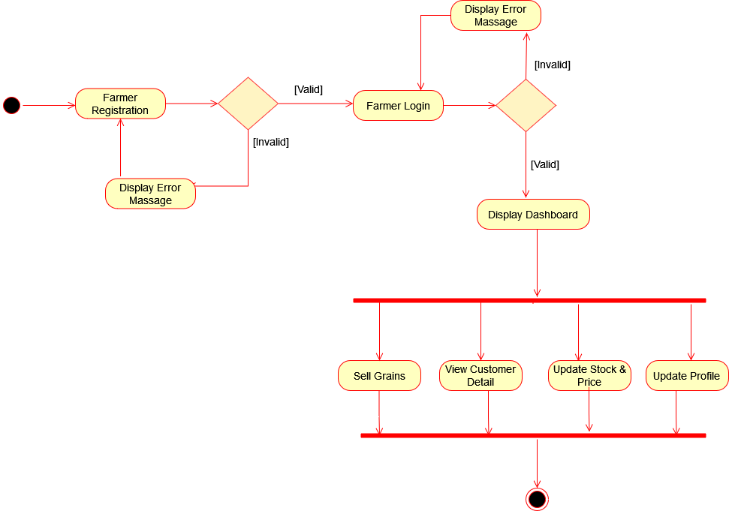

ACTIVITY DIAGRAM FOR ORDER

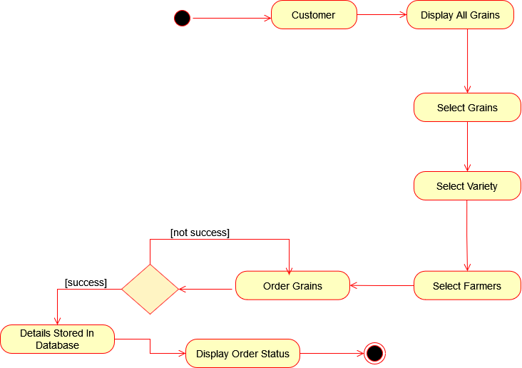

ACTIVITY DIAGRAM FOR PAYMENT AND DELIVERY

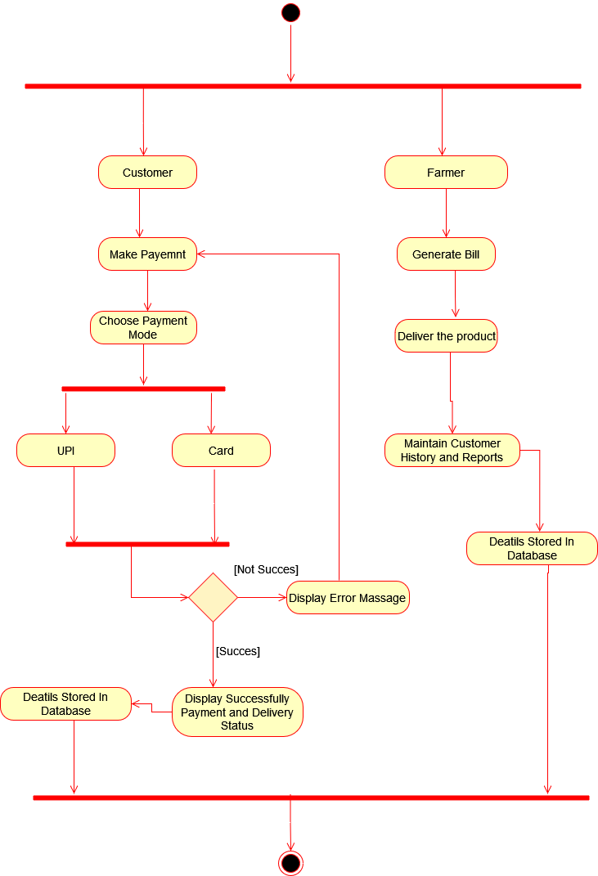

ACTIVITY DIAGRAM FOR GRAINS

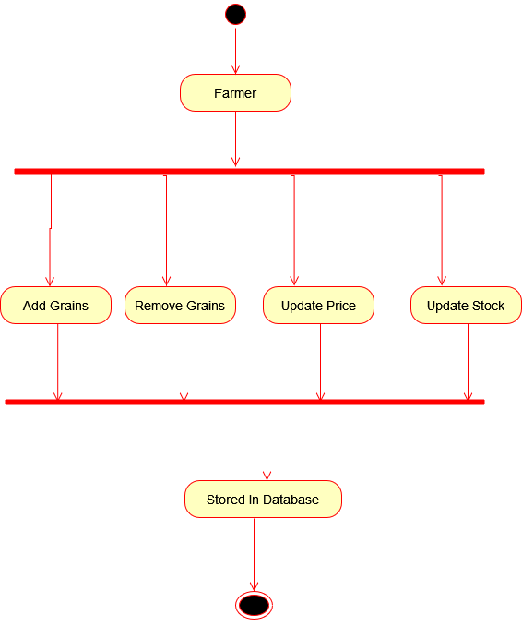

**3.5 Sequence Diagram**

SEQUENCE DIAGRAM OF CUSTOMER

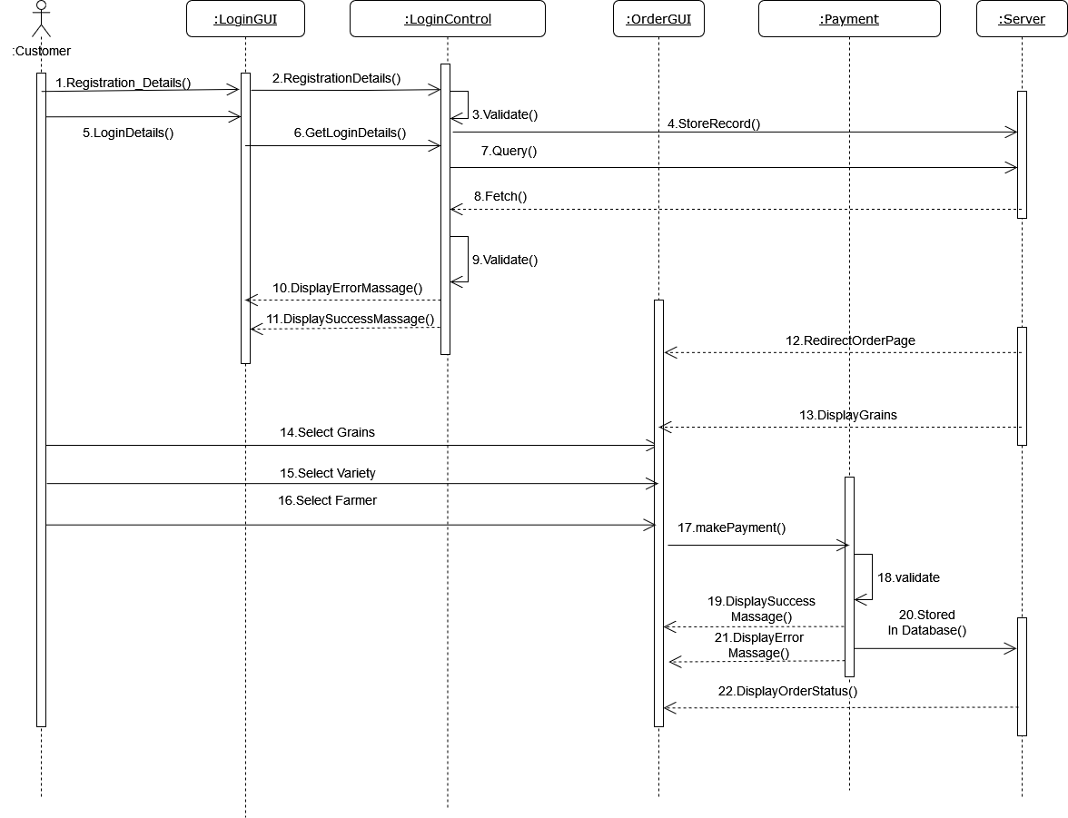

SEQUENCE DIAGRAM OF FARMER

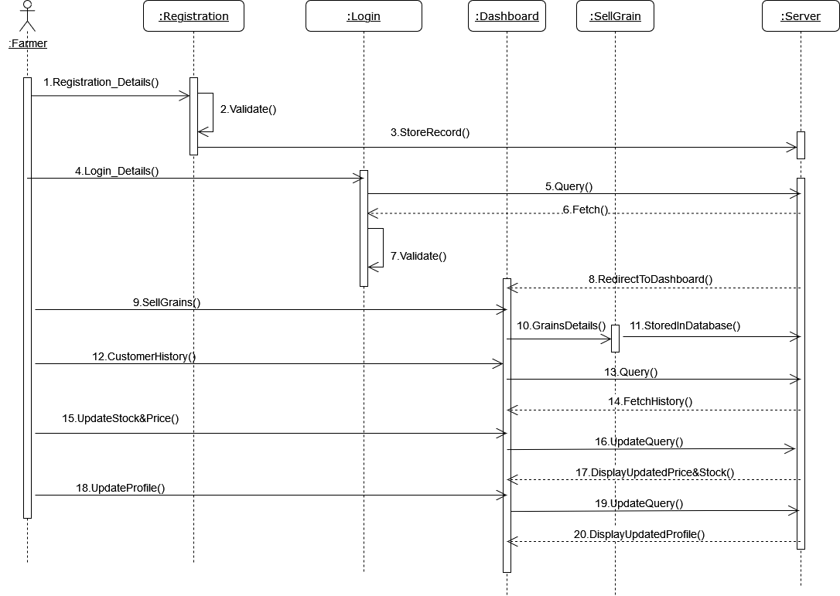

SEQUENCE DIAGRAM OF ORDER



SEQUENCE DIAGRAM FOR PAYMENT AND DELIVERY

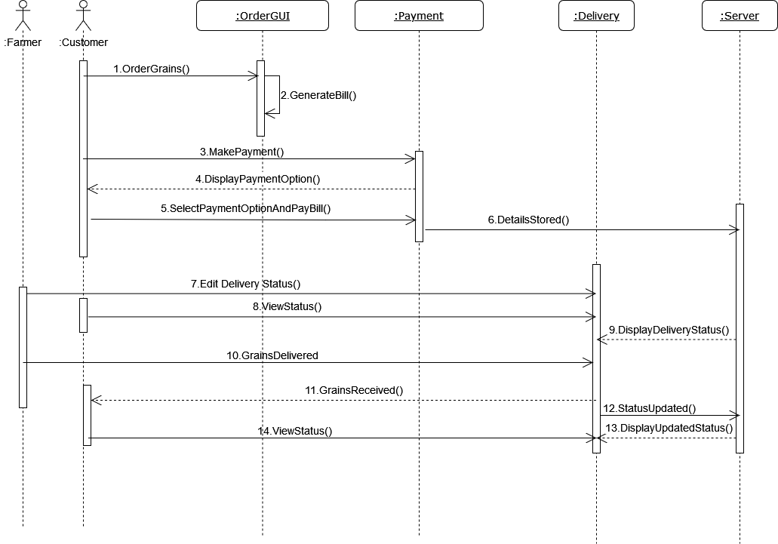

SEQUENCE DIAGRAM FOR GRAINS

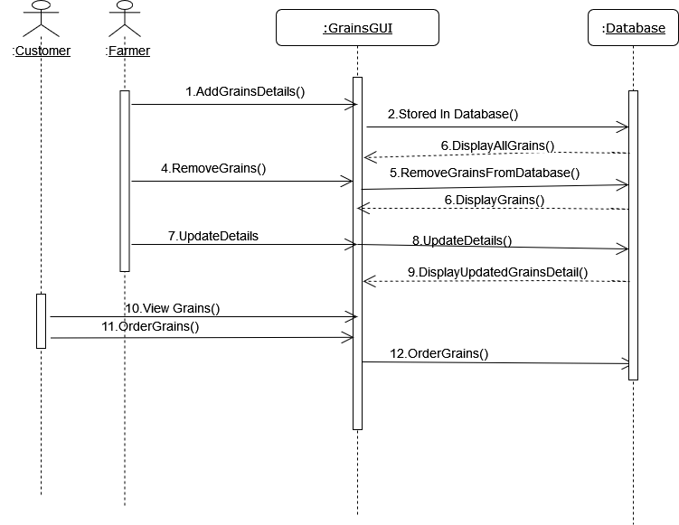

**3.6 Component Diagram**

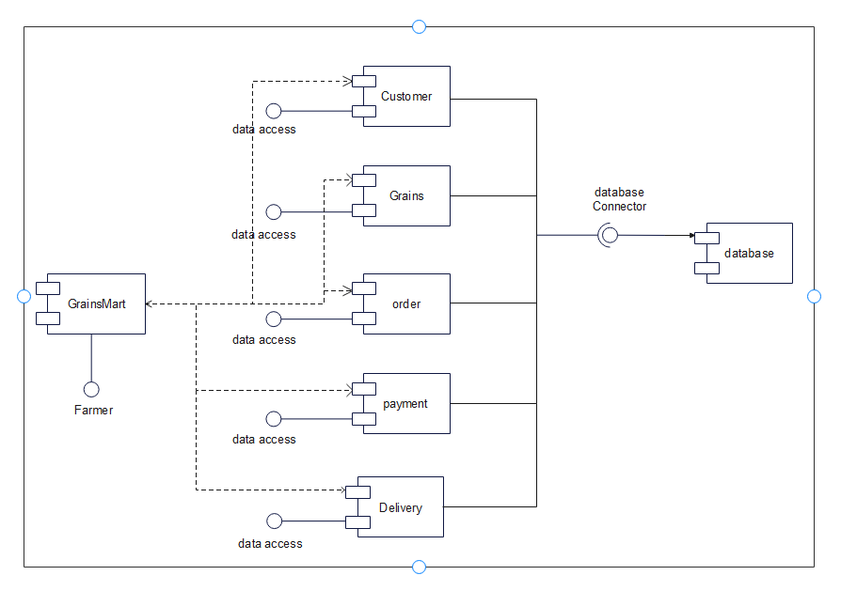

**3.7 Table Design**

TABLE NAME: Customer

|  |  |  |  |
| --- | --- | --- | --- |
| **Field name** | **Datatype** | **Size** | **Constraints** |
| C_id | int | 10 | Primary key |
| C_username | varchar | 10 | Not null |
| C_password | varchar | 12 | Not null |
| C_Name | varchar | 10 | Not null |
| C_email | varchar | 20 | Not null |
| C_MobileNo | int | 10 | Not null |
| C_Address | varchar | 20 | Not null |

TABLE NAME: Farmer

|  |  |  |  |
| --- | --- | --- | --- |
| **Field name** | **Datatype** | **Size** | **Constraints** |
| f_id | int | 10 | Primary key |
| f_username | varchar | 10 | Not null |
| f_password | varchar | 12 | Not null |
| f_Name | varchar | 10 | Not null |
| f_email | varchar | 20 | Not null |
| f_MobileNo | int | 10 | Not null |
| f_Address | varchar | 20 | Not null |

TABLE NAME: Orders

|  |  |  |  |
| --- | --- | --- | --- |
| **Field name** | **Datatype** | **Size** | **Constraints** |
| Order_id | int | 10 | Primary Key |
| Grains_id | int | 10 | Foreign key |
| C_id | int | 10 | Foreign Key |
| F_id | int | 10 | Foreign key |
| Order_quantity | int | 5 | Not null |
| Total_bill | int | 10 | Not null |
| Order_Date_time | date | -- | Not null |
| Delivery_address | varchar | 20 | Not null |

TABLE NAME: Grains

|  |  |  |  |
| --- | --- | --- | --- |
| **Field name** | **Datatype** | **Size** | **Constraints** |
| Grain_id | int | 10 | Primary key |
| Grain_Name | varchar | 20 | Not null |
| Grain_Variety | varchar | 20 | Not null |
| Grain_price | int | 10 | Not null |
| Total_Stock | int | 10 | Not null |

TABLE NAME: Payments

|  |  |  |  |
| --- | --- | --- | --- |
| **Field name** | **Datatype** | **Size** | **Constraints** |
| Payment_id | int | 10 | Primary key |
| Order_id | int | 10 | Foreign key |
| C_id | int | 10 | Foreign key |

**3.8 Data Dictionary**

|  |  |  |  |  |  |
| --- | --- | --- | --- | --- | --- |
| **Field name** | **Datatype** | **Size** | **Constraints** | **Description** | **Table Name** |
| f_id | int | 10 | Primary key | Represent Farmer Id | Farmer,Orders |
| f_username | varchar | 10 | Not null | Represent Farmer Username | Farmer |
| f_password | varchar | 12 | Not null | Represent Farmer login password | Farmer |
| f_Name | varchar | 10 | Not null | Represent Farmer name | Farmer |
| f_email | varchar | 20 | Not null | Represent Farmer email | Farmer |
| f_MobileNo | int | 10 | Not null | Represent Farmer MobileNo | Farmer |
| f_Address | varchar | 20 | Not null | Represent Farmer Address | Farmer |
| C_id | int | 10 | Primary key | Represent Customer Id | Customer,Orders,Payments |
| C_username | varchar | 10 | Not null | Represent Customer Username | Customer |
| C_password | varchar | 12 | Not null | Represent Customer password | Customer |
| C_Name | varchar | 10 | Not null | Represent Customer name | Customer |
| C_email | varchar | 20 | Not null | Represent Customer email | Customer |
| C_MobileNo | int | 10 | Not null | Represent Customer MobileNo | Customer |
| C_Address | varchar | 20 | Not null | Represent Customer Address | Customer |
| Order_id | int | 10 | Primary Key | Represent Order Id | Orders,Payments |
| Order_quantity | int | 5 | Not null | Represent Order Quantity | Orders |
| Total_bill | int | 10 | Not null | Represent Total Bill | Orders |
| Order_Date_time | date | -- | Not null | Represent Order Date&Time | Orders |
| Delivery_address | varchar | 20 | Not null | Represent Delivery Address | Orders |
| Grain_id | int | 10 | Primary key | Represent Grain id | Grains,Orders |
| Grain_Name | varchar | 20 | Not null | Represent Grain Name | Grains |
| Grain_Variety | varchar | 20 | Not null | Represent Grain Variety | Grains |
| Grain_price | int | 10 | Not null | Represent Grain price | Grains |
| Total_Stock | int | 10 | Not null | Represent Total Stock | Grains |
| Payment_id | int | 10 | Primary key | Represent Payment Id | Payments |

**3.9 Sample Input and Output Screens**

* **Home Page**

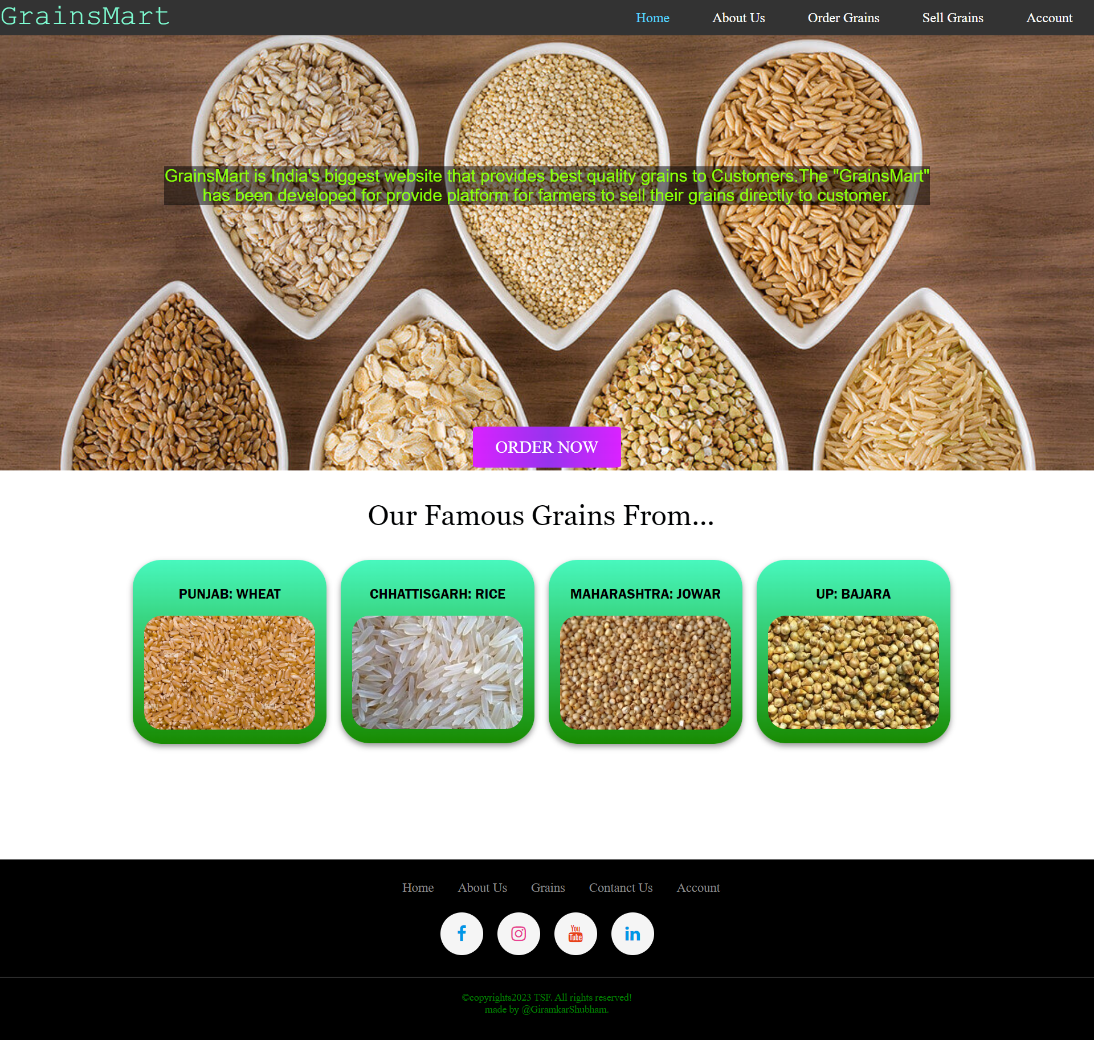

* **AboutUs Page**

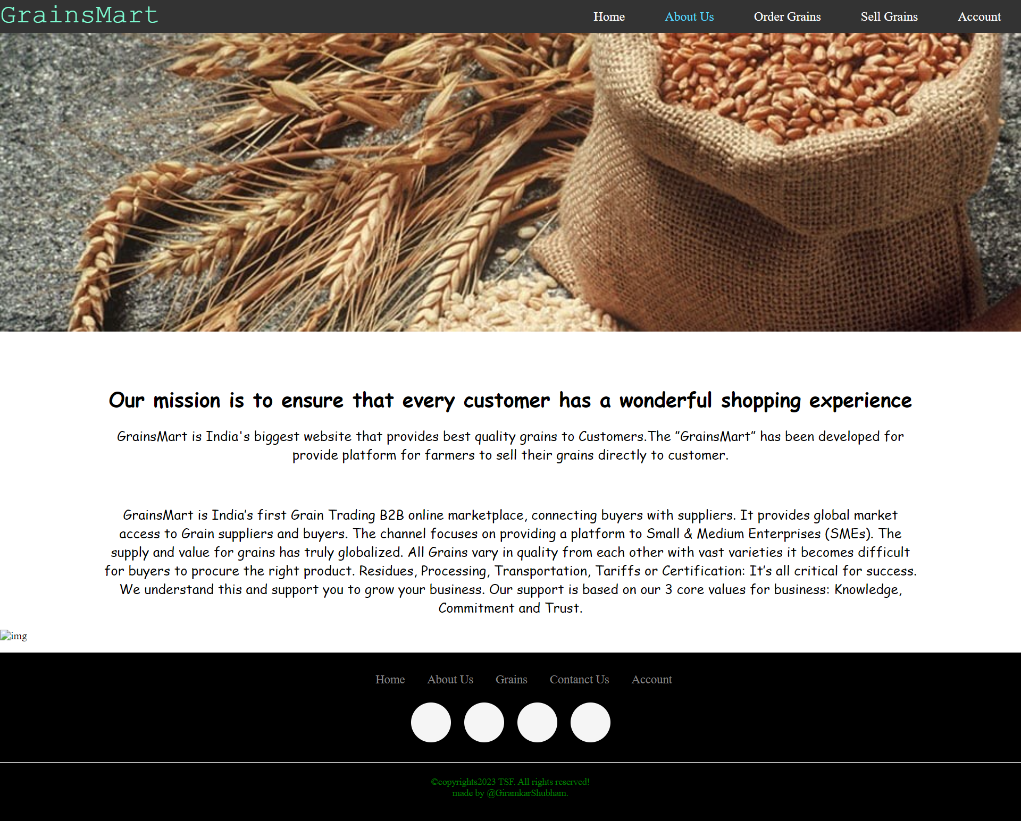

* **Customer Register Page**

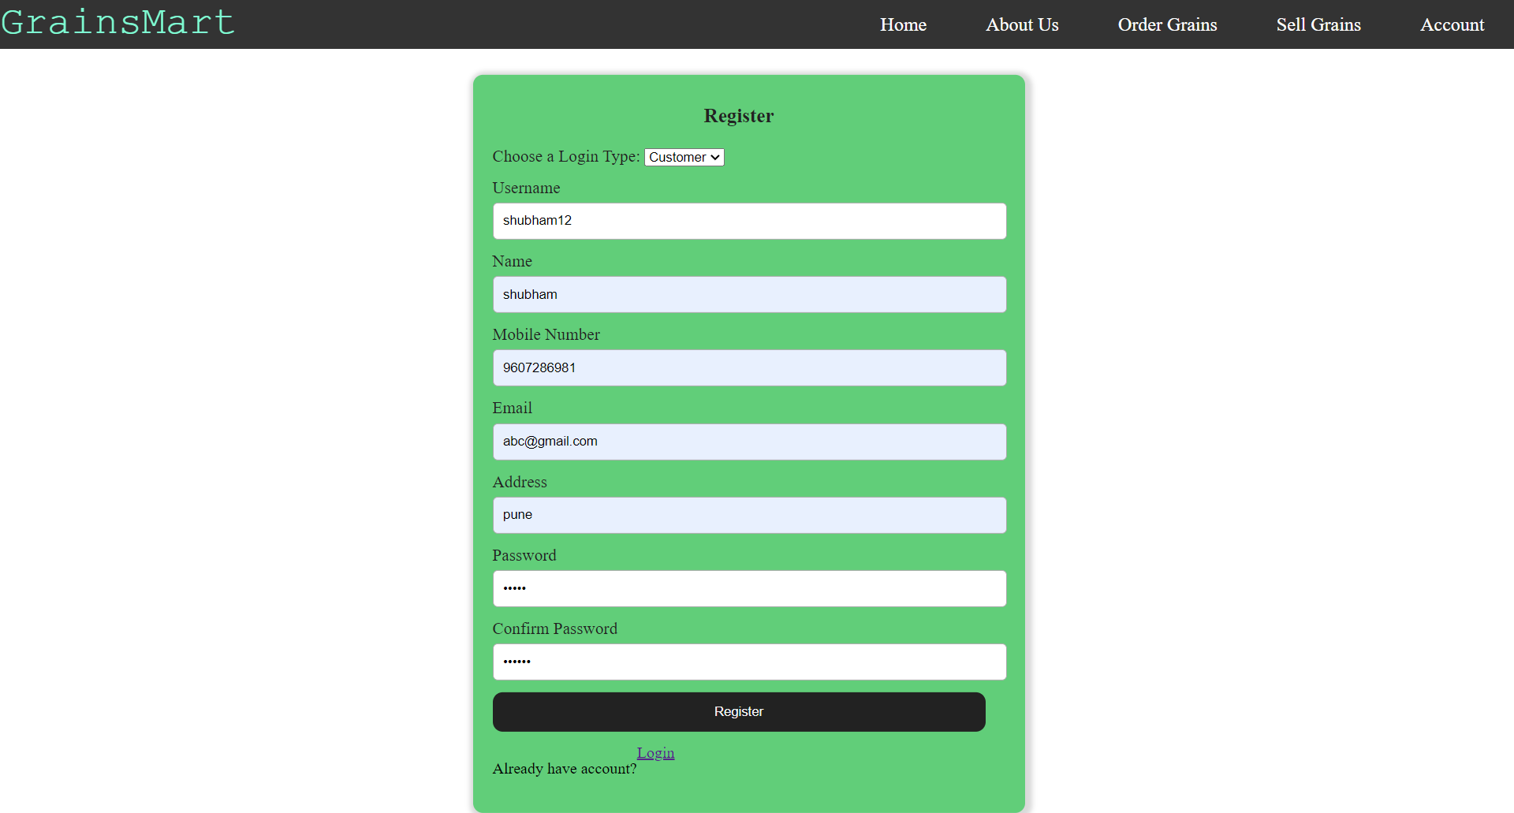

* **Customer Login Page**

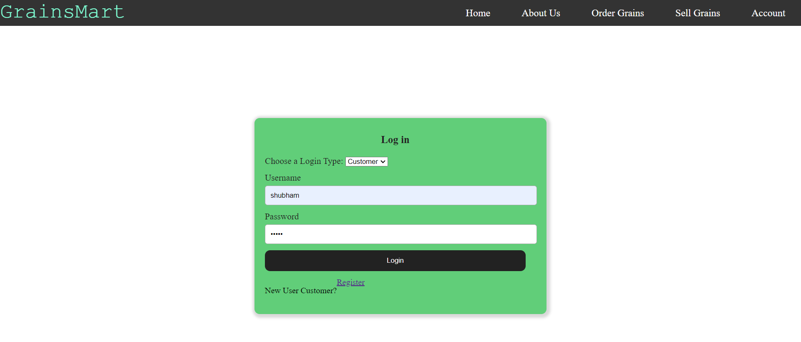

* **Grains Page**
* 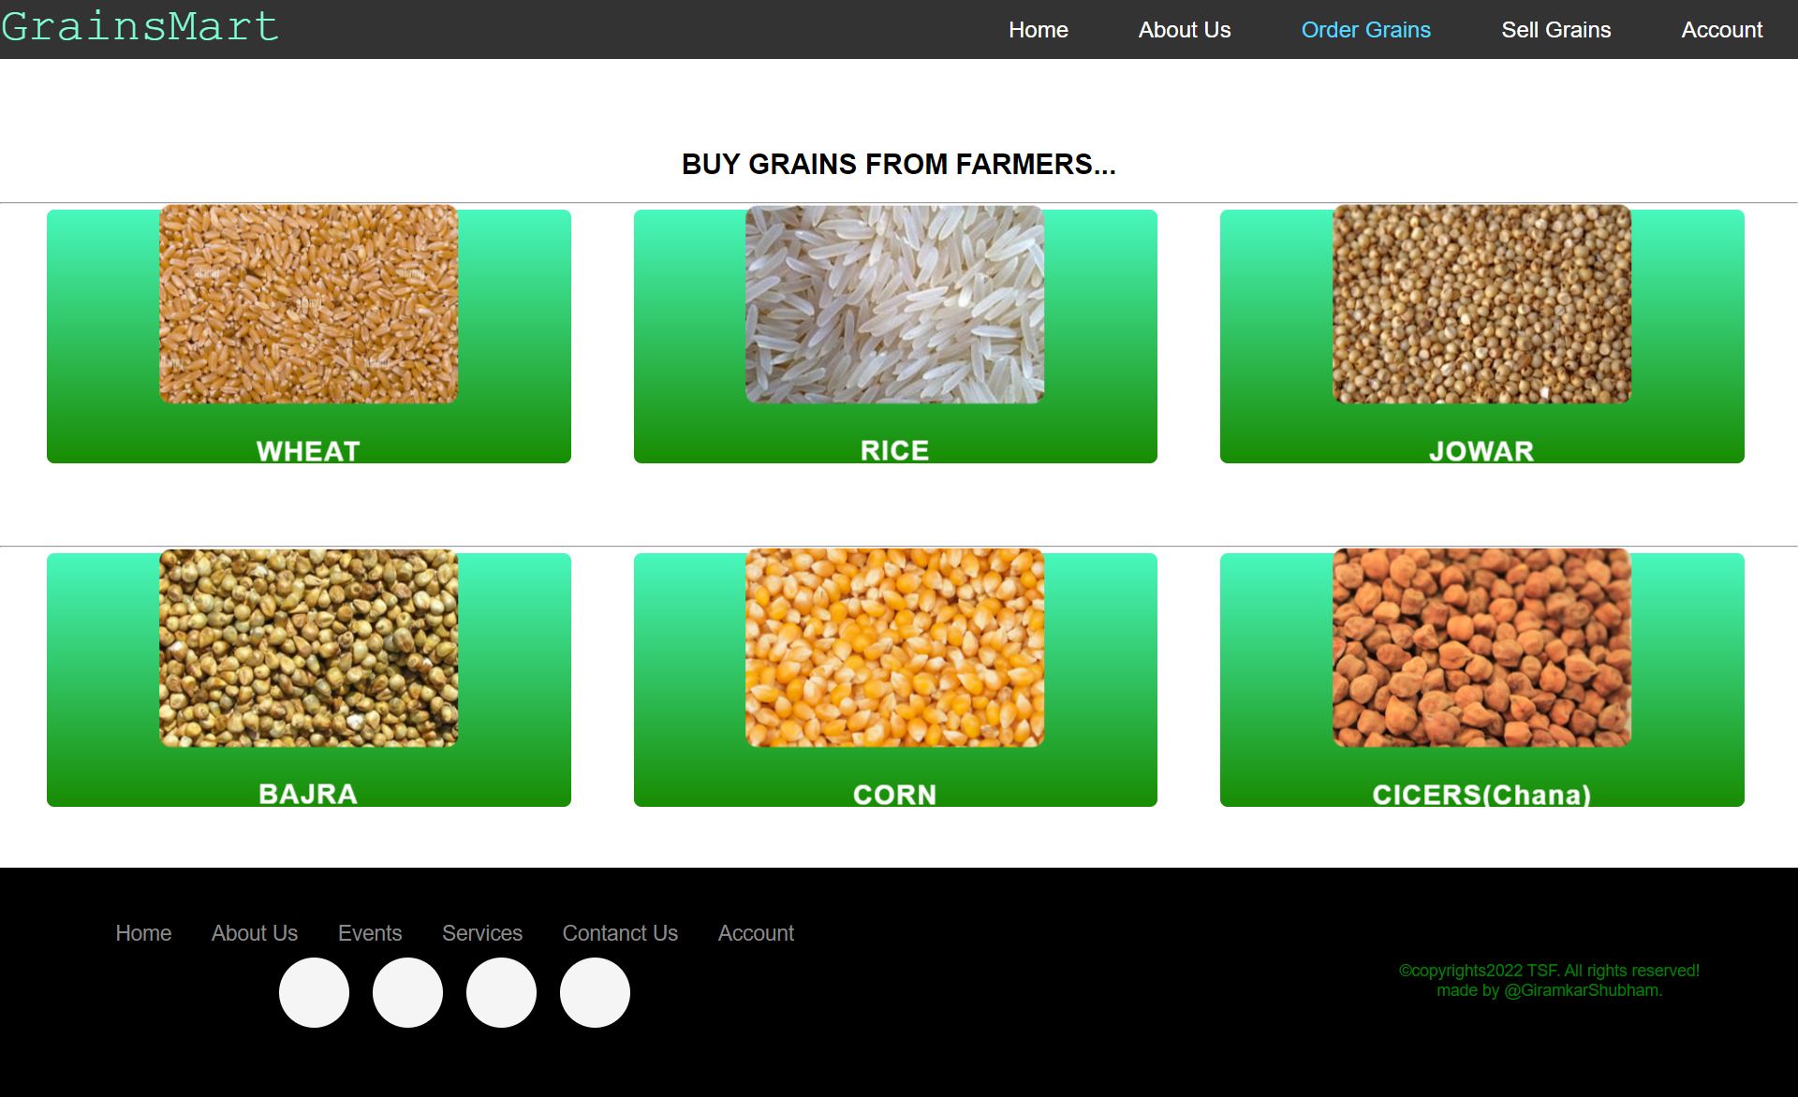
* **Select Farmer & Grains Page**

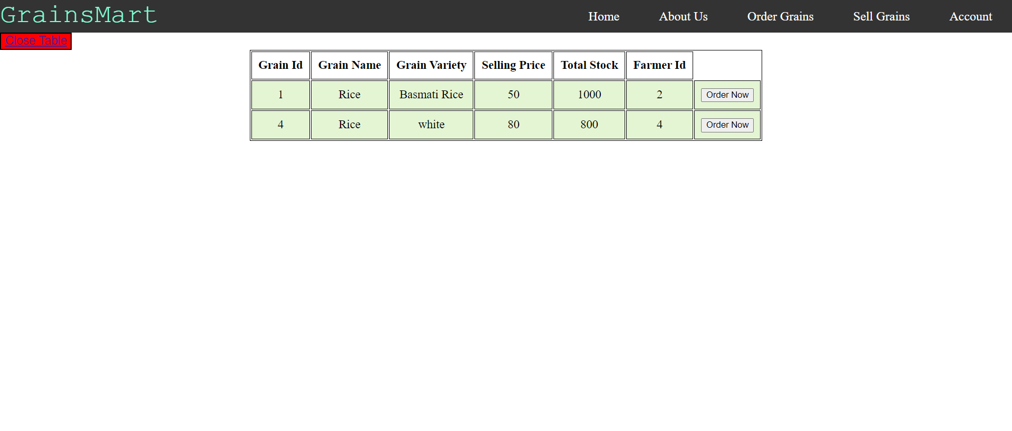

* **Order Grains Page**

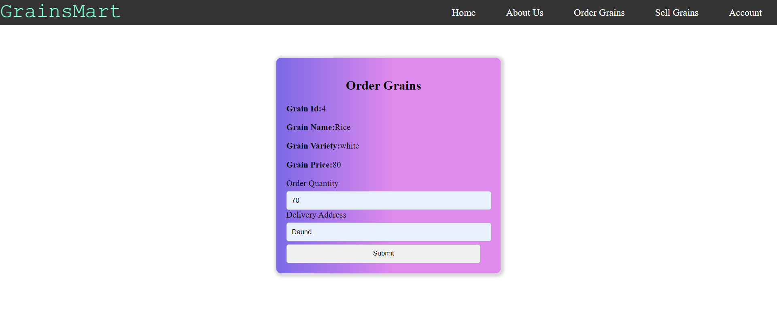

* **Bill Page**

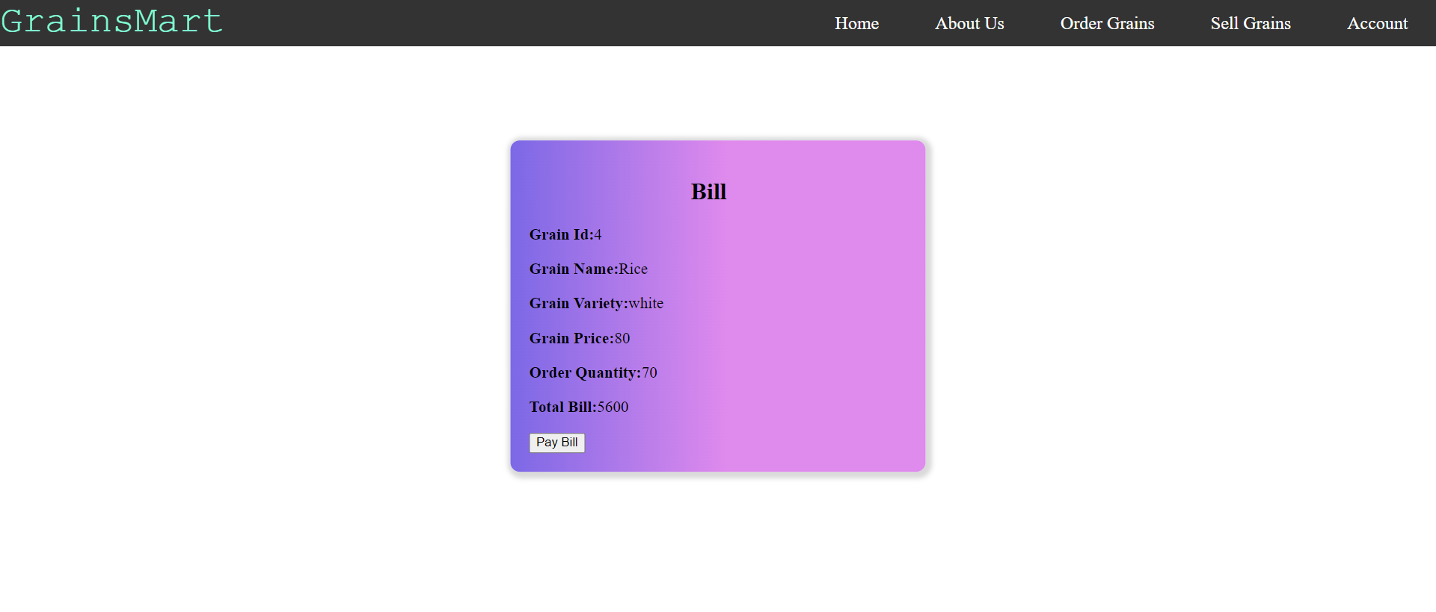

* **Order Recived Page**

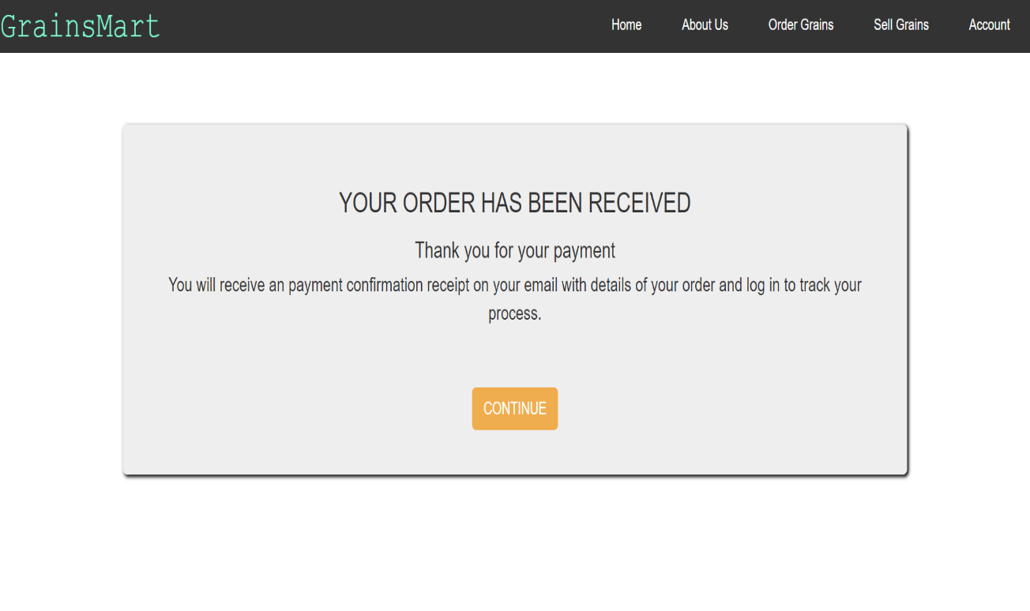

* **Customer Dashboard Page**

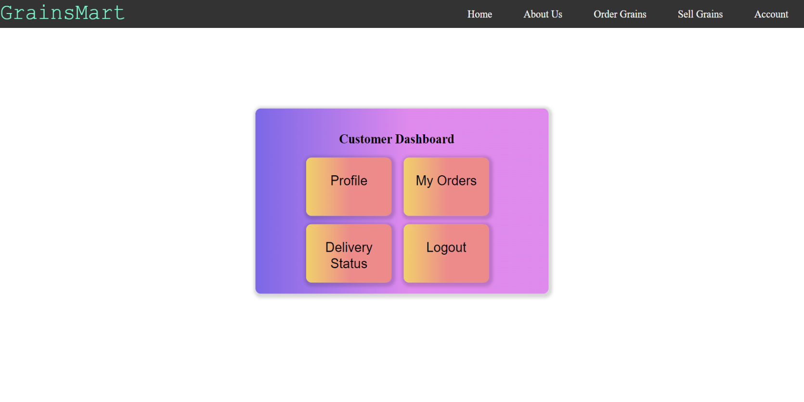

* **Customer Profile Page**

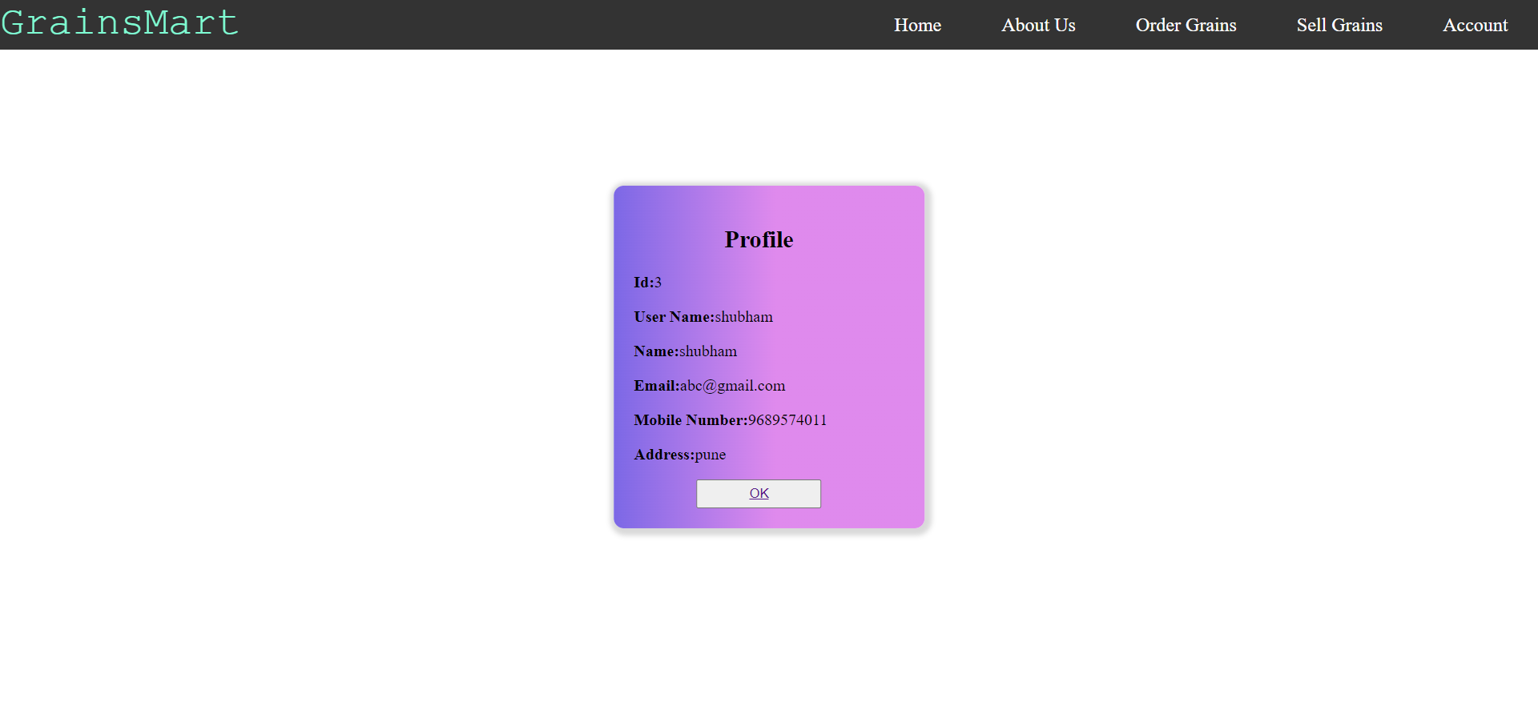

* **Customer MyOrders Page**

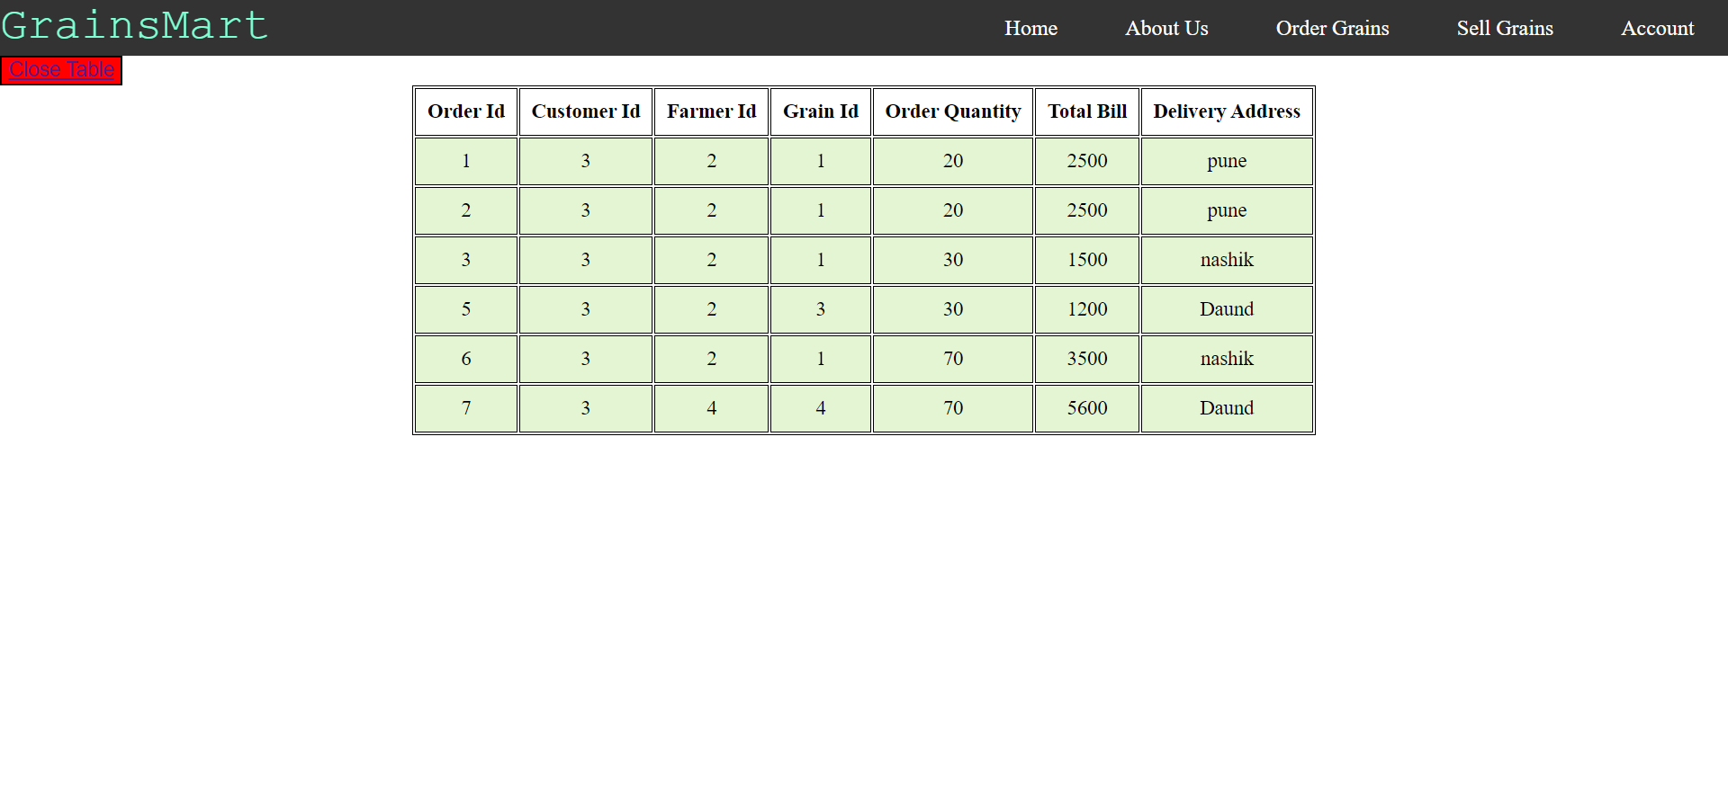

* **Farmer Register Page**

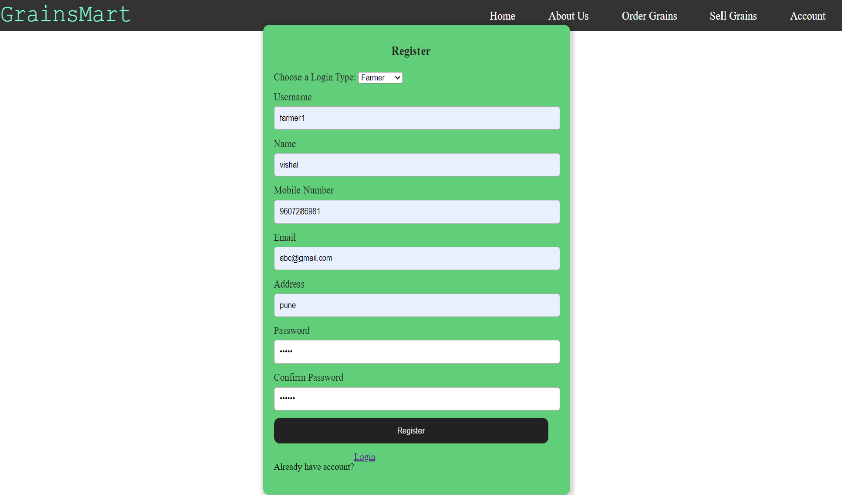

* **Farmer Login Page**

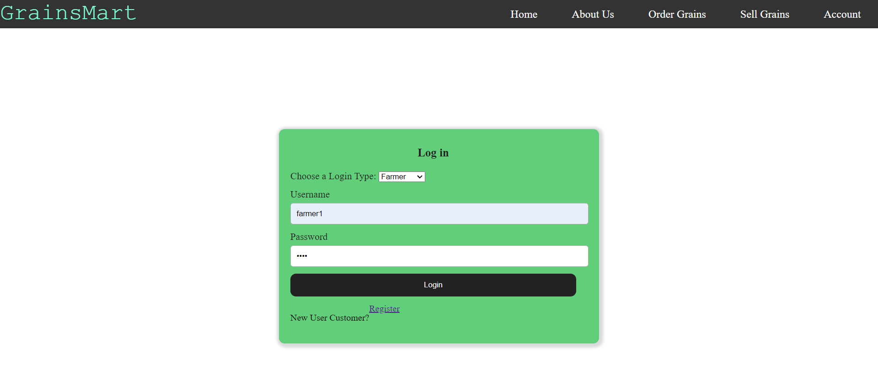

* **Sell Grains Page**

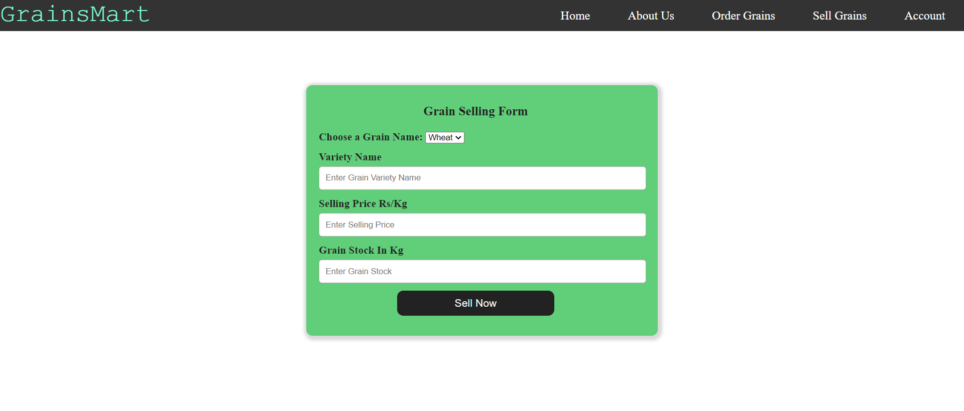

* **Farmer Dashboard Page**

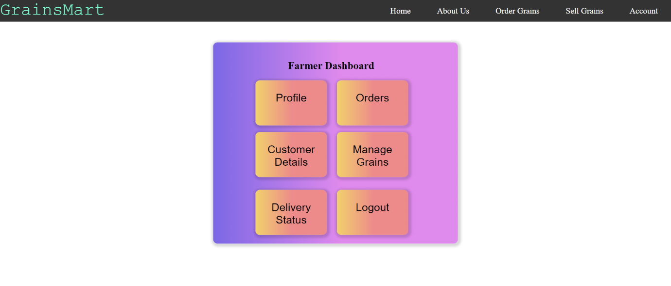

* **Farmer Profile Page**

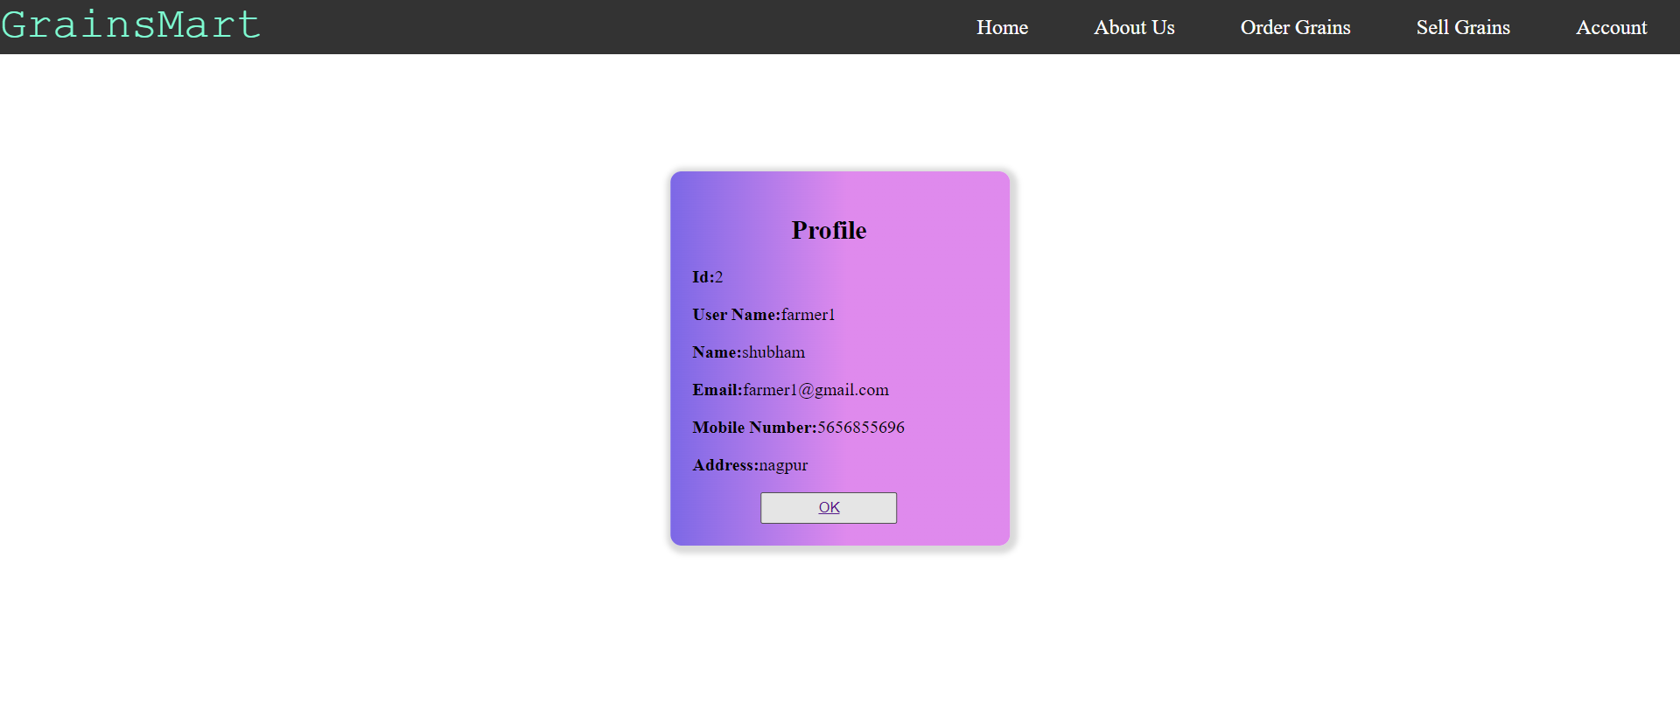

* **Total Orders Page**

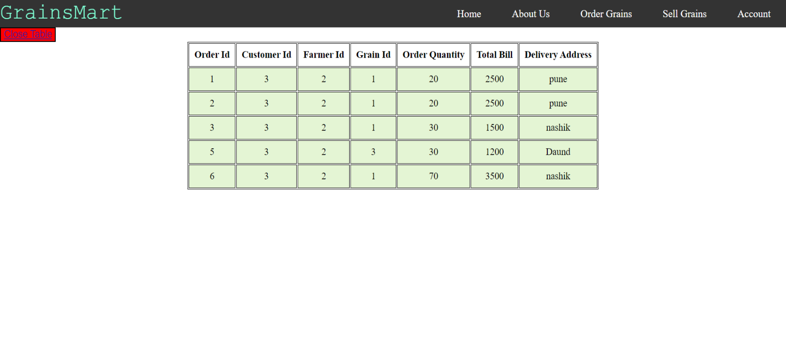

* **Manage Grains Page**

